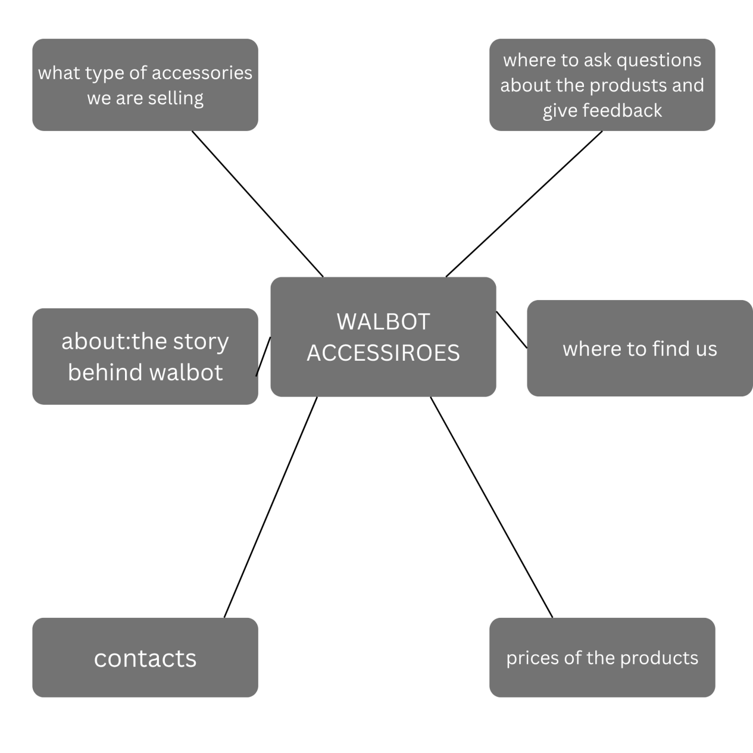

Stage 1: Define
figure out what the website is supposed to achieve. You ask the big questions: Why are we building this? Who is it for? What do we want people to do when they get here?

- Understanding that students, remote workers, and professionals need affordable, quality laptop accessories
- Recognising that the current social media-only approach is limiting growth
Setting clear goals: increase sales by 30%, build brand trust, grow the email list (Chaffey and Ellis-Chadwick, 2019, p. 112)
- What problem does this website solve?
- Who are our users and what do they need?
- What actions do we want users to take?
- How will we measure success?

Stage 2: Plan
- Creating a sitemap showing all pages and how they connect
- Organising files and folders logically
- Researching content and gathering images
- Planning the navigation structure
- Setting up a realistic timeline

Stage 3: Design
decide what the website will look like. Colours, fonts, layout, and user experience all come together here (Williams, 2022, p. 112).
- Choosing the colour scheme (charcoal, orange, white)
- Selecting fonts (clean, modern sans-serif)
- Creating wireframes to visualise the layout
- Planning responsive behaviour for different devices

Stage 4: Build
you actually write the code. HTML for structure, CSS for styling, and JavaScript for functionality (Krug, 2014, p. 156).

Stage 5: Launch
test everything, fix any issues, and deploy the website for the world to see (Nielsen, 2022, p. 189).
- Testing on different browsers and devices
- Optimising for search engines (SEO)
- Deploying on a free platform like Netlify
- Submitting the final project

